all-in-one HUMAN CAPITAL MANAGEMENT SYSTEM: bossc

Flexible, Customizable, Scalable. Administer anything with benefitOS.
HR and Benefits administration is a complex business. You are challenged on all fronts by market uncertainty, increased competition and decreasing margins.
Your clients need a trusted advisor to guide them through a shifting mosaic of industry, political and technological disruption, compliance and provider consolidation. There’re too many choices, too much administration, and too little time.
So, what if we told you that there is a product that will simplify the complexity, speed up the process and increase productivity? There is a simple and elegant solution that is affordable. It could help you increase your net revenue and grow your client base substantially.
You see we’ve got a disruptive solution of our own. It’s called benefitOS and we’ve built it just for you.
The overall design of benefitOS allows us to quickly and easily configure the underlying platform to be able to administer any service.

FULLY EQUIPPED BENEFITS ADMINISTRATION
- Employee enrolment capabilities (Life Event, New Hire, Annual Enrolment) including Decision Support Tools
- Employee and dependent transactions
- Health, Dental, Life Insurance and Disability administration
- Voluntary Benefits administration
- ACA Reporting (US Clients Only)
- Employee deductions and payroll reporting
- Carrier and Premium Reporting
- Integration with 3rd party providers such as carriers
- Configuration Capabilities such as:
  - Plan Rules and Eligibility Configuration
  - Out-of-the-box Fields or Create New Fields
  - Imports (including Scheduling and Notification capabilities)
  - Reports (including Scheduling and Notification capabilities)
  - Customization of Documents
  - Create New Enrolments
  - Manage & Schedule Jobs
  - Create Configuration and Plan Requirements
  - And much more...

In addition to offering a industry leading platform - BOSSC offers world class services that range from full outsourcing capabilities to augmenting existing teams with services when required.

BOSSC’s approach and experience allows them to partner with all organizations and offer the services that best suit that group. We have implemented services for regional brokers, small enterprises and Fortune 100 organizations.

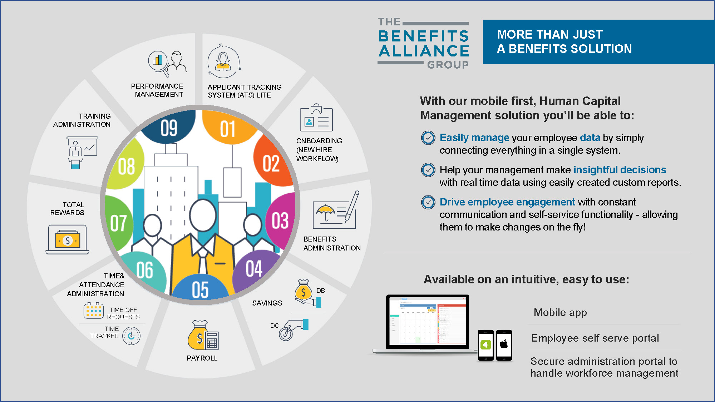

ABOUT BOSSC
BOSSC Inc. innovates software solutions and improves business processes which generate high quality solutions and results for its customers.

BOSSC Inc. is a leader in software development and implementation of enterprise-level solutions with core values that include happy clients, motivated people and high-quality service.

Our mission is to deliver services that help our customers be more efficient and generate better bottom line results by allowing them to focus on their core businesses while we focus on the rest.

