cloudadvisors™

Digitizing Insurance, Simplifying Advice
CloudAdvisors connects insurance advisors with marketplace data and the best tools in a secure digital platform for an enhanced client experience.
Insurance Advisors Augmented by Technology to Deliver Simple and Smart Advice.
Insurance and Retirement plans (Employee Benefits) impact millions of lives. Employers responsible for making decisions rely on expert advice and need more than just a broker.
Why? CloudAdvisors believe advisors, augmented by technology, will help employers make better decisions for their people.
Purpose: To digitize insurance brokerage and democratize the most effective advice.
Vision: To create an accessible and intelligent advice assistant for better insurance advice.

Digital Client Management
Client, Prospect and Contact Details, Timeline Tracking, Benefit and Retirement Plan Designs.

On-Demand Insights
Analyze, Rank, and Compare Employee Benefits Across Thousands of Employers In Seconds.

Automated Reporting
Create client reports in seconds from templates, upload all client files and access anywhere in a secure cloud platform.

Governance and Compliance
Track Events with Clients, Meeting Notes, Considerations and Recommendations, Know Your Client Process, Annual Governance and Renewal Checklists.
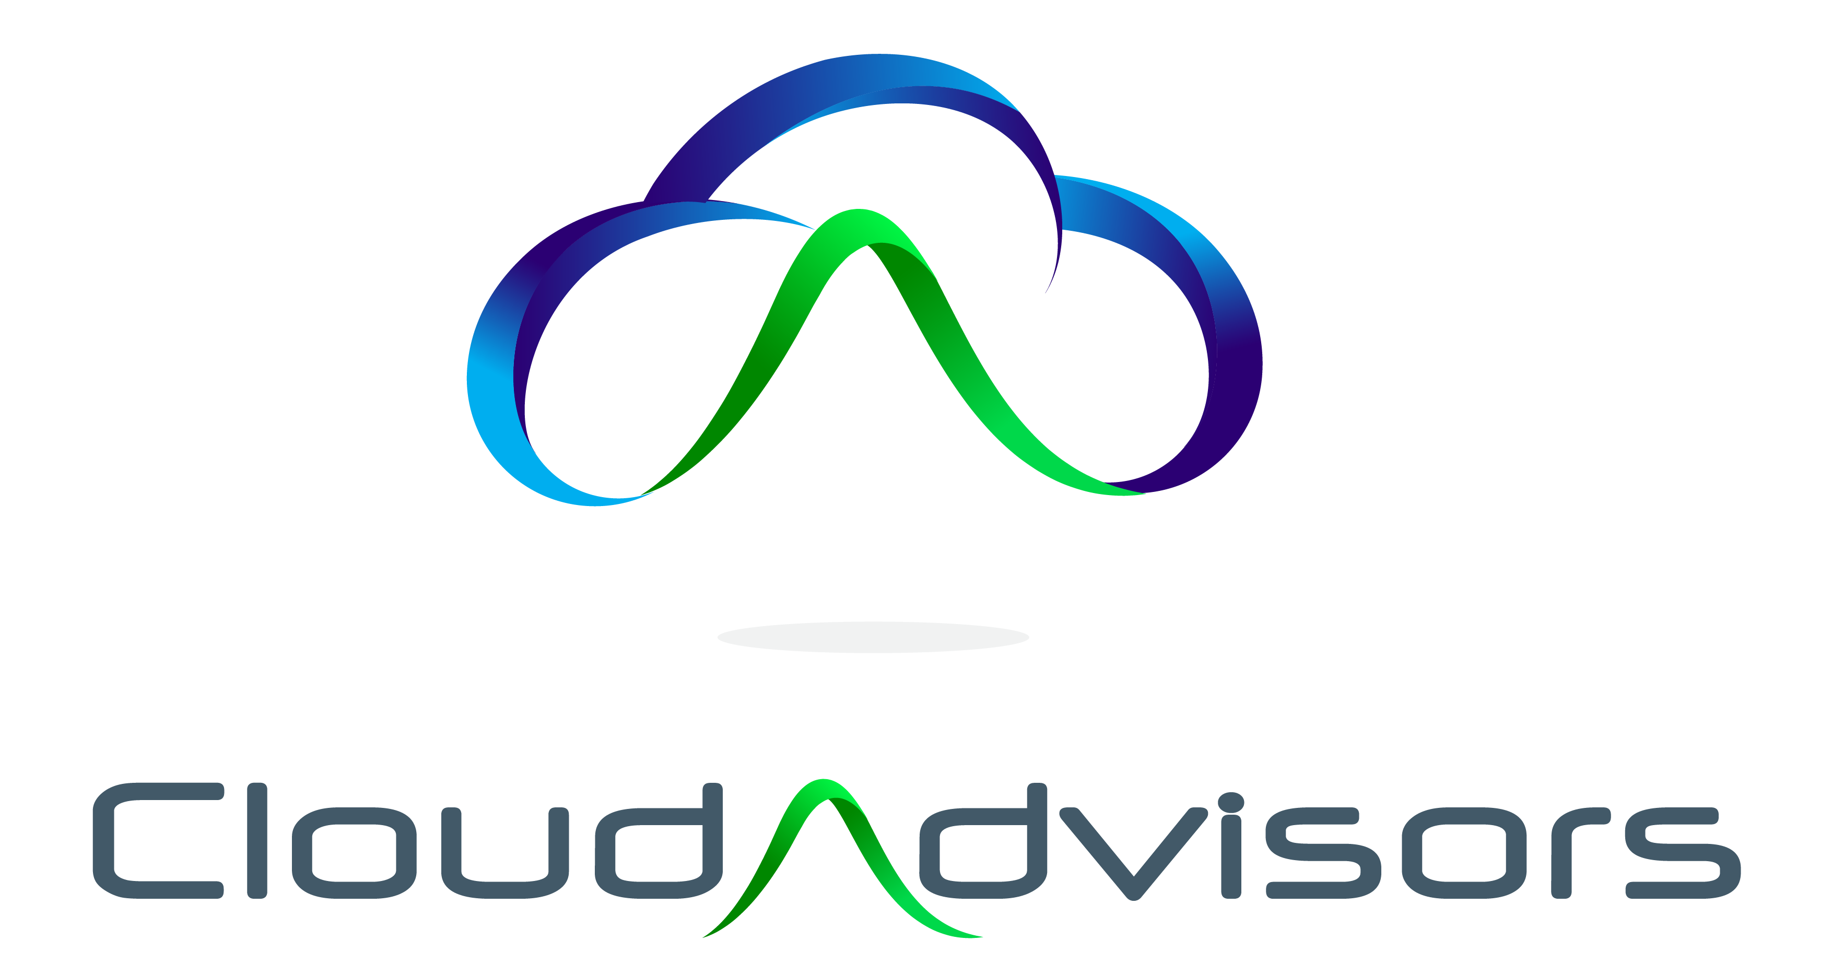
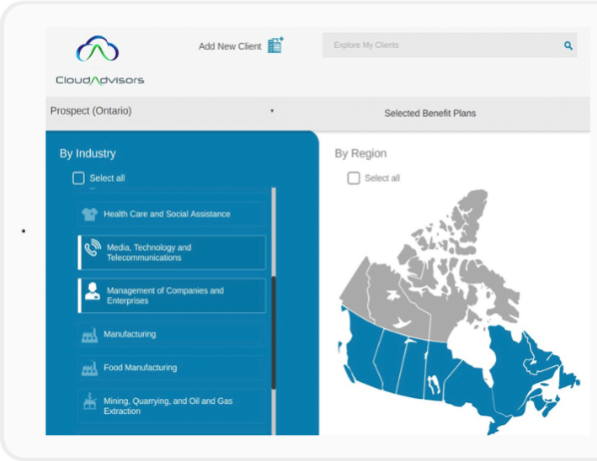

sample benchmarking: Long Term Disability

