RWAM PRoducts & Services
RWAM works exclusively with a network of highly qualified Employee Benet Advisors. This Preferred Advisor network off-era professional advice to our mutual client base.

Products
RWAM offers traditional employee benefits such as Life Insurance, Accidental Death and Dismemberment, Dependent Life Insurance, Short and Long-term Disability, Prescription Drug Plans, Practitioner and Hospital coverage, Vision Care, Dental and Critical Illness. In addition to traditional benefits, we offer a wide-range of benefits such as Employee Assistance Plans, Medical Second Opinion services, Disability Management, Health Spending Accounts. Employers can elect to use various funding arrangements, such as prospectively rated, Administrative Services Only (ASO) or Profit Participation and incorporate risk management tools such as Stop Loss.

Underwriting Philosophy
RWAM’s underwriting philosophy is known across the benefits industry as being “fair”. RWAM reviews each renewal to ensure a consistent approach to pricing, taking into account actual claims history. Groups who have positive claims experience are renewed favourably and groups demonstrating high levels of claims experience are brought into line with the usage they are exhibiting.

Benefits Administration
RWAM has a sophisticated Group Benefits Administration System that allows us the ability to handle a broad scope of benefit plan designs. Each group has an assigned team of administrators that are available to assist with any type of inquiry. For the convenience of plan administrators that prefer to process transactions electronically, RWAM has a convenient, user-friendly On-Line Administration system where one-on-one training is offered.

Claims Adjudication
Our team of claims adjudicators have extensive experience in this field. Adjudicators are cross trained in all areas so to understand the complexities that exist in all claims payment. RWAM utilizes the latest in real time claims adjudication to ensure that employees receive their payments in the least amount of time possible.

Disability Management
RWAM Disability Management has the expertise and information our clients need to take control of disability matters. Our experienced staff provide answers to employer’s most urgent questions: the standard expected claims duration, the potential for long term disability, and the best approach to disability management.

Plan Member Services
RAWM’s state of the art Plan Member Website provides employees with easy access to member information, coverage overview, claim submission and claims history via desktop or mobile device.
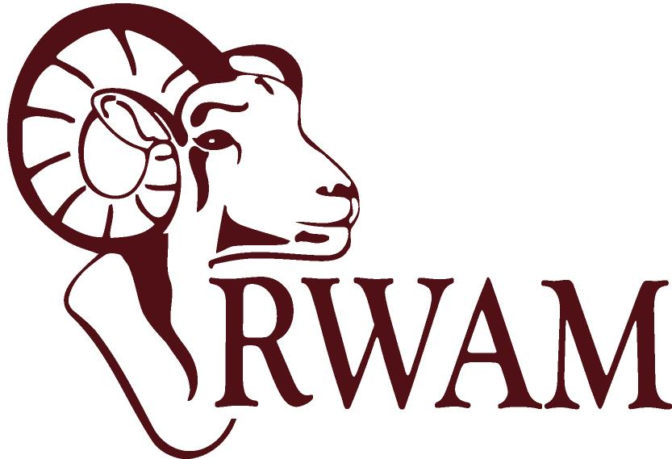

Solid Business Practices
For over 30 years, our business philosophy and practices have earned us the reputation of being a competitive provider that takes pride in building long-term relationships. As a founding member of TPAAC (Third Party Administrators Association of Canada), we promote best practices and professional conduct for our industry to protect the trust that plan sponsors place in us. With a focus on continually striving for excellence, RWAM prides itself on flexibility and responsiveness as we continually face shifting market conditions.

THE PODIUM PLAN
A comprehensive Employee Benefit Package designed specifically to address the ever-increasing cost to Employers in offering group insurance benefits to their employees.
The Podium Plan offers three specifically designed packages, that will fit the benefit needs of employers with a work force of between 3 and 25 employees.
The plan design features built in cost containment, which will protect benefit duplication between an employer sponsored group plan and the benefits that may be available through Provincial/Territory government plans. The Podium Plan will ensure the cost of your group plan remains stable and sustainable for the years to come, while maintaining a cost structure that is affordable now and into the future.
Distributed exclusively through The Benefits Alliance Group, a national network of 40-member firms and over 100 employee benefit Advisors committed to integrity, professionalism and high-quality advice.

ELIGIBILITY REQUIREMENTS
All Benefits as described in the Summary of Benefits are mandatory, except Dental and Long Term Disability. Life, AD&D, Dependent Life reduce by 50% at age 65 and terminate at age 70. The Extended Health and Dental Care benefits terminate at age 75. Long Term Disability terminates at age 65. The group must either be a legally incorporated company, sole proprietorship or partnership, with true employer / employee relationships.
The group must be in business for a minimum of one year. All employees and their dependents must be insured under their Provincial Health Insurance Plan. Pre-Authorized Debit is mandatory. All full-time employees (min. 20 hrs per week) must be enrolled on the plan. 100% participation if less than 10 lives, 75% participation if 10 or more lives. Some occupations are not eligible for Long Term Disability coverage due to the nature of the risk.

BENEFIT PROVIDERS
The Podium Plan is administered by RWAM Insurance Administrators Inc., one of the largest full service third party administrators of employee benefits in Canada. Life Insurance, Dependent Life, Long Term Disability, Extended Health Care and Dental Benefits are underwritten and insured by La Capitale Insurance. Accidental Death and Dismemberment is underwritten and insured by Chubb Life Insurance Company of Canada. Allianz Global Assistance provides the Emergency Out-of-Province / Country Benefit.

For more information and rates, please contact your RWAM representative.

