compcall disability management specialists

Concerned about rising LTD costs?

Medical management impacts disability outcomes.
Many employers are frustrated by escalating employee disability costs. They are looking for new and better solutions to help expedite their employees’ recovery and successful return to work, while containing costs.
The traditional methods of managing employee Disability claims, either in-house or through and insurer, no longer address today’s challenges. Realities such as delays in the healthcare system and continued legislative changes protecting employee privacy rights have led to rapidly rising claims costs for employers.

Employers need a better solution and here’s how we can help…

Market Philosophy: There is a Long Term Disability Problem
The market has shown when companies invest little into their Short Term Disability management the results equate to a lot more money and time spent on Long Term Disability. Without the right initial coverage employers risk encountering limited return to work planning and higher Long Term Disability rates to solve the same problem.
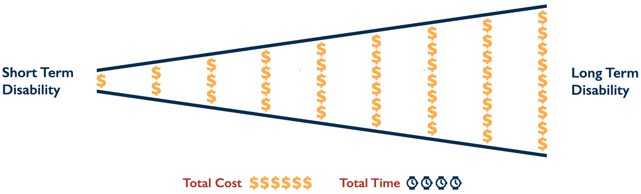

CompCall Philosophy: There is a Short Term Disability Problem
CompCall’s ActiveCare™ provides employers with a choice – a truly proactive medical management model that moves away from the traditional Disability Management approach.
The premise is simple. If you medically manage the STD period, the LTD takes care of itself.

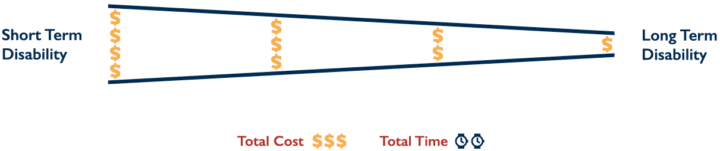

Partnering For Success

ActiveCare™ … making a difference through:
- Proactive claims management
- Assistance in navigating the healthcare system
- Ready access to CompCall’s national medical provider network
- A fee structure that aligns CompCall’s interests with the employer – getting employees back to work sooner

Don’t Offer STD Coverage?
Consider adding employee or employer funded Medical management to assist employees while they are on EI.

www.compcall.com 1-888-466-8577

